|  |  |
| --- | --- |
| AIM: | Experiment using Cisco Packet Tracer |

EXPERIMENT: 10

THEORY:

* + - * **What is Cisco Packet Tracer?**

Cisco Packet Tracer is Cisco's simulation software. It can be used to create complicated network typologies, as well as to test and simulate abstract networking concepts. It acts as a playground for you to explore networking and the experience is very close to what you see in computer networks.

They also provide their service in languages such as Russian, German, Spanish and French. Packet Tracer enables students to create complicated and huge networks, which is frequently impossible with physical hardware due to cost considerations. Packet Tracer is available for Linux, Windows, MacOS, Android, and iOS. Packet Tracer allows users to drag and drop routers, switches, and other network devices to create simulated network topologies The best way to learn about networking, according to Cisco, is to do it. This programme cannot replace hardware routers or switches because the protocols are implemented solely in software. This tool, however, does not just contain Cisco hardware but also a wide range of other networking devices.

Network topology is the arrangement of the elements of a communication network. Network topology can be used to define or describe the arrangement of various types of telecommunication networks, including command and control radio networks and computer networks.

Topology Diagram

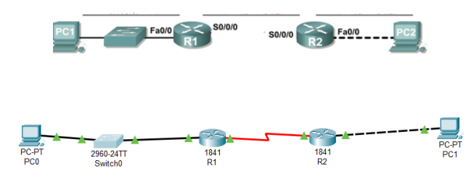

Addressing Table

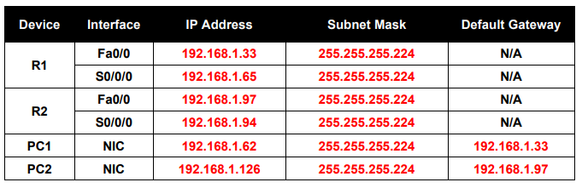

Learning Objectives:

* + - * Subnet an address space given requirements.
      * Assign appropriate addresses to interfaces and document.
      * Configure and activate Serial and FastEthernet interfaces.
      * Test and verify configurations.
      * Reflect upon and document the network implementation.

Scenario:

In this lab activity, you will design and apply an IP addressing scheme for the topology shown in the Topology Diagram. You will be given one address block that you must subnet to provide a logical addressing scheme for the network. The routers will then be ready for interface address configuration according to your IP addressing scheme. When the configuration is complete, verify that the network is working properly

IMPLEMENTATION:

Installation of packet tracer. Sign up and install.



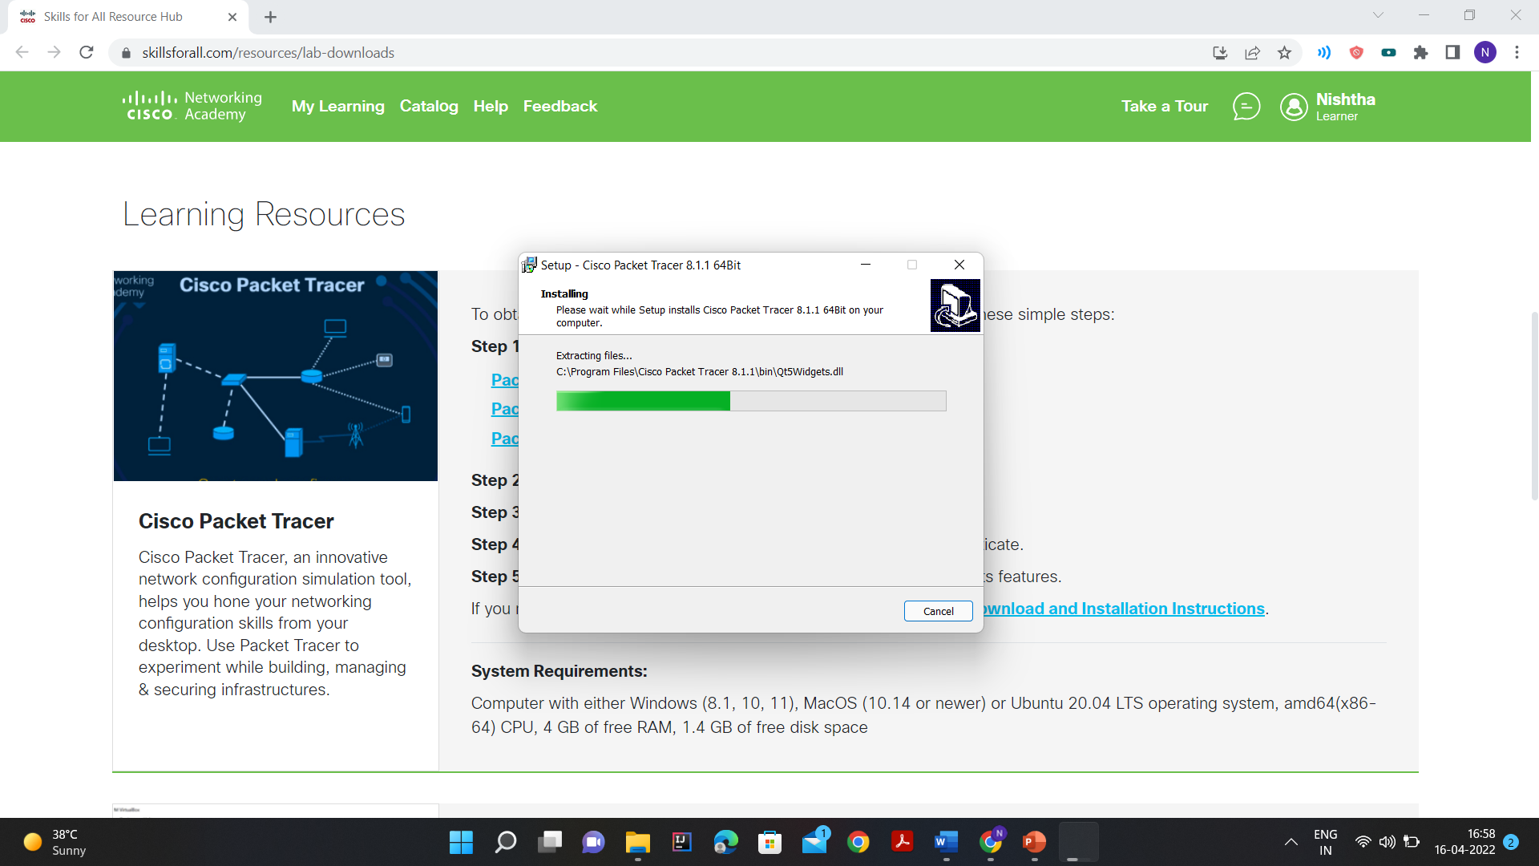

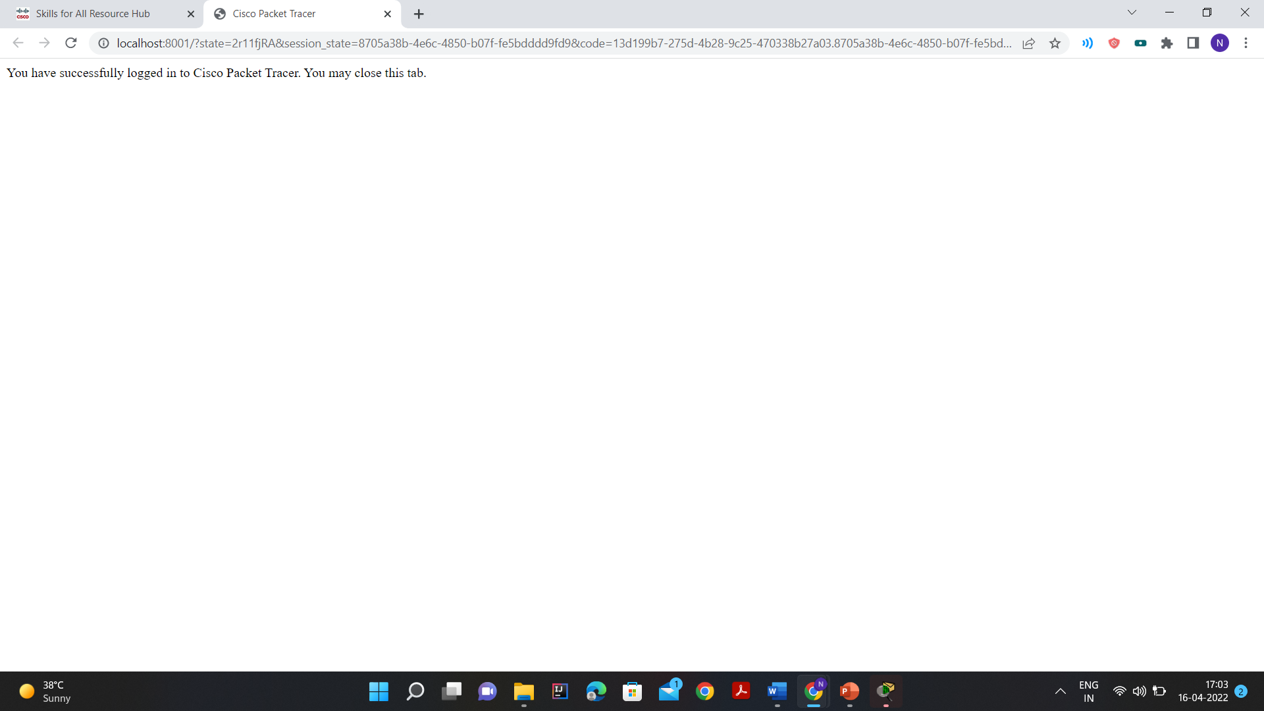

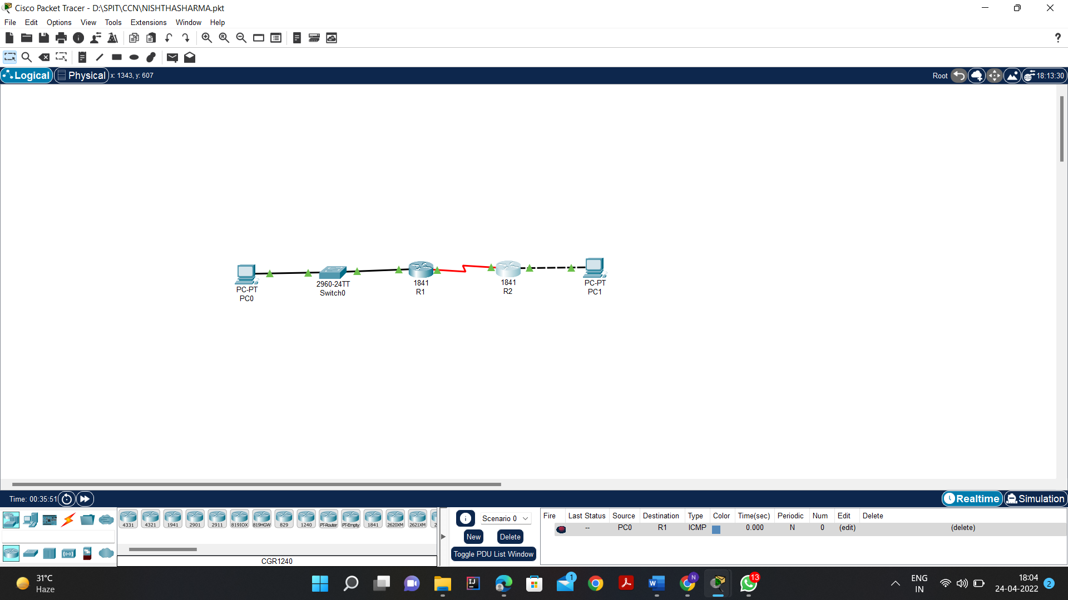

**Task 1: Subnet the Address Space.**

1. Examine the network requirements.

You have been given the 192.168.1.0/24 address space to use in your network design. The network consists of the following segments:

* The network connected to router R1 will require enough IP addresses to support 15 hosts.
* The network connected to router R2 will require enough IP addresses to support 30 hosts.
* The link between router R1 and router R2 will require IP addresses at each end of the link.

1. Consider the following questions when creating your network design.
2. How many subnets are needed for this network?

* 3 Subnets are required for this network

1. What is the subnet mask for this network in dotted decimal format?

* 255.255.255.224 is the subnet mask

1. What is the subnet mask for the network in slash format?

* /27 is the subnet mask in slash format for this address.

1. How many usable hosts are there per subnet?

* 30 usable hosts are there per subnet

1. Assign subnetwork addresses to the Topology Diagram.

* Assign subnet 1 to the network attached to R1
* 192.168.1.32/27
* Assign subnet 2 to the link between R1 and R2
* 192.168.1.64/27
* Assign subnet 3 to the network attached to R2
* 192.168.1.96/27

**Task 2: Determine Interface Addresses.**

1. Assign appropriate addresses to the device interfaces.
2. Assign the first valid host address in subnet 1 to the LAN interface on R1 i.e., 192.168.1.33

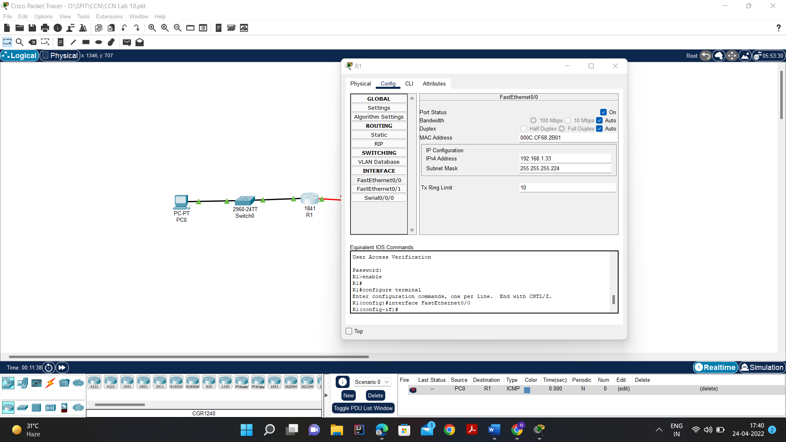

1. Assign the last valid host address in subnet 1 to PC1 i.e., 192.168.1.62

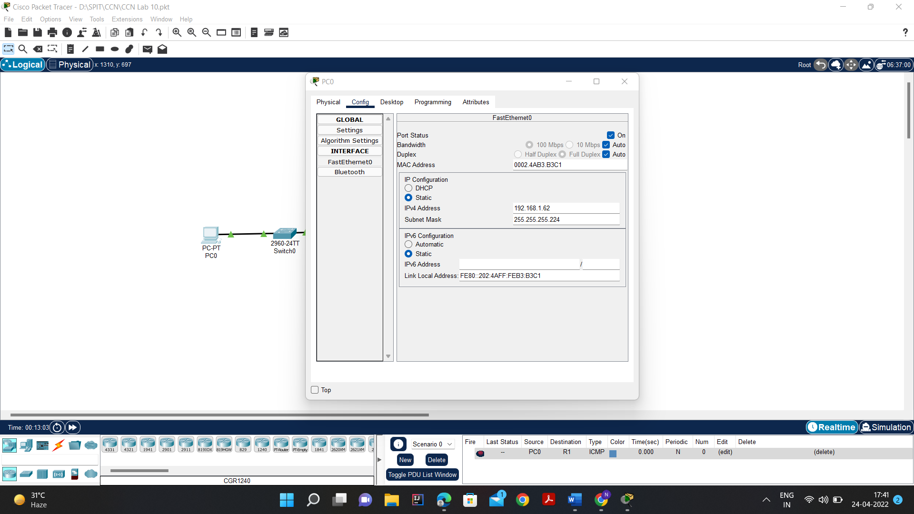

1. Assign the first valid host address in subnet 2 to the WAN interface on R1 i.e., 192.168.1.65

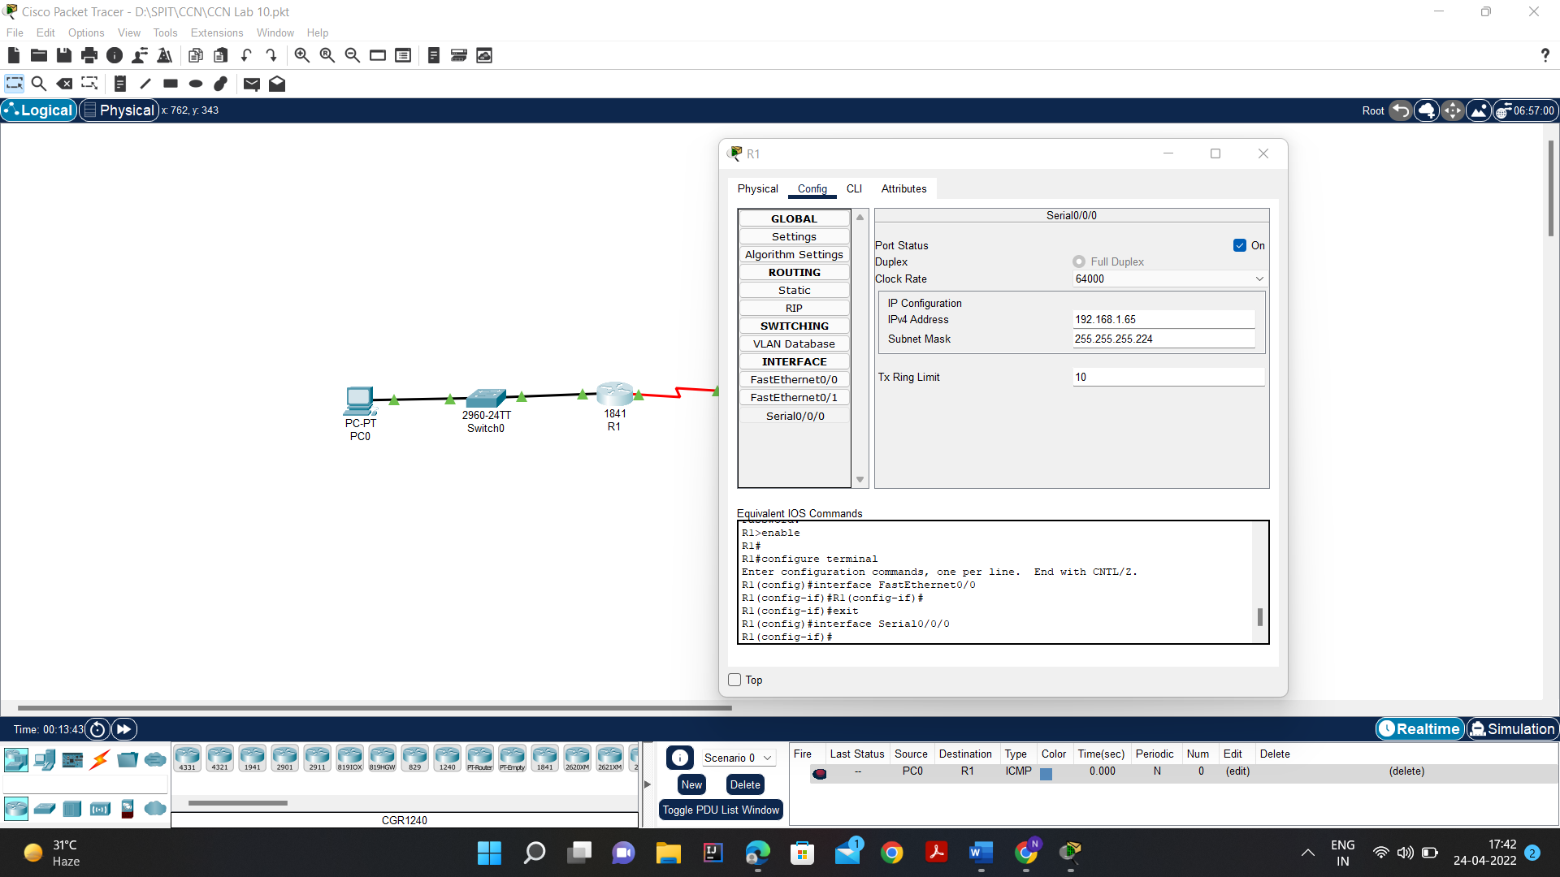

1. Assign the last valid host address in subnet 2 to the WAN interface on R2 i.e., 192.168.1.94

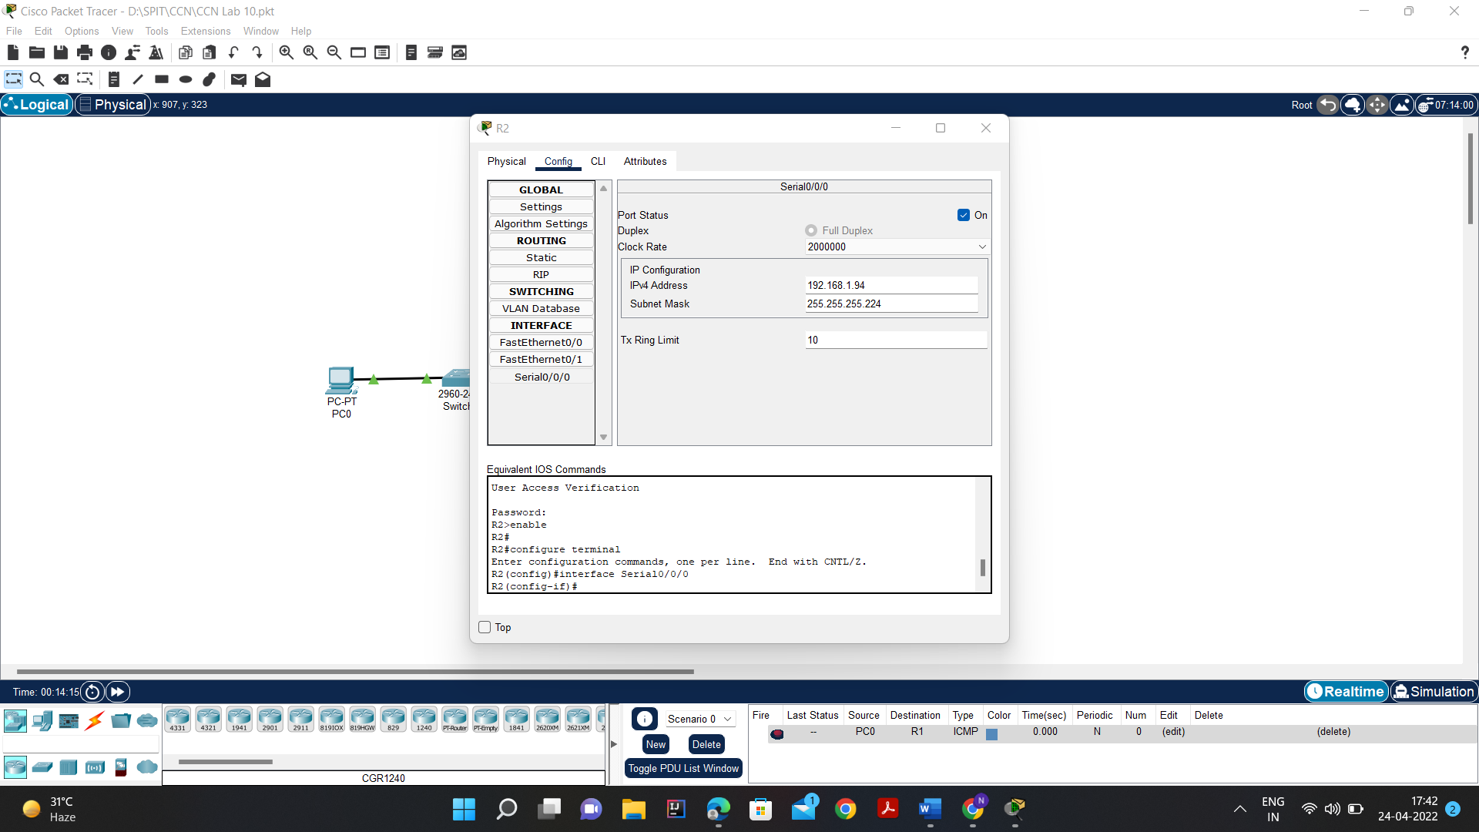

1. Assign the first valid host address in subnet 3 to the LAN interface of R2 i.e., 192.168.1.97

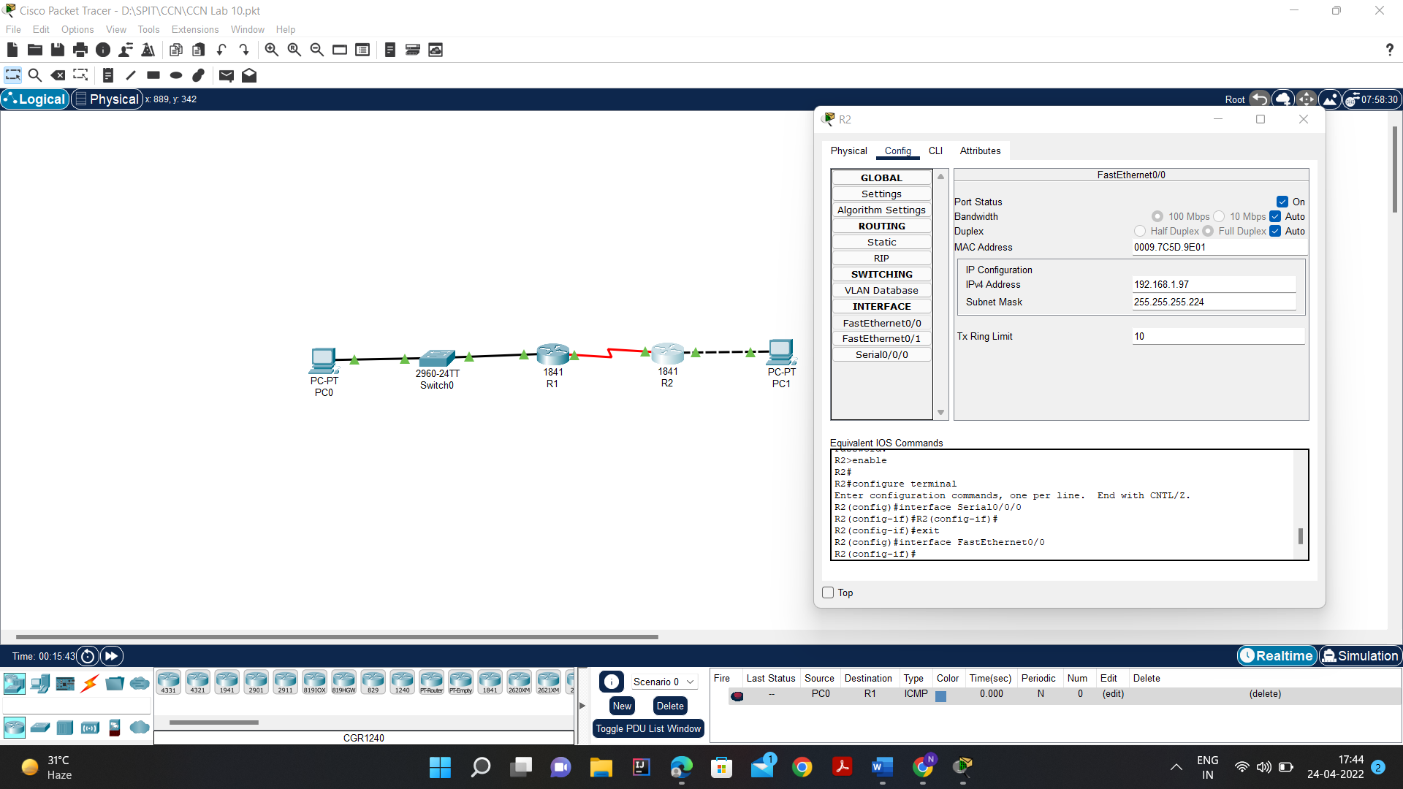

6. Assign the last valid host address in subnet 3 to PC2 i.e., 192.168.1.126

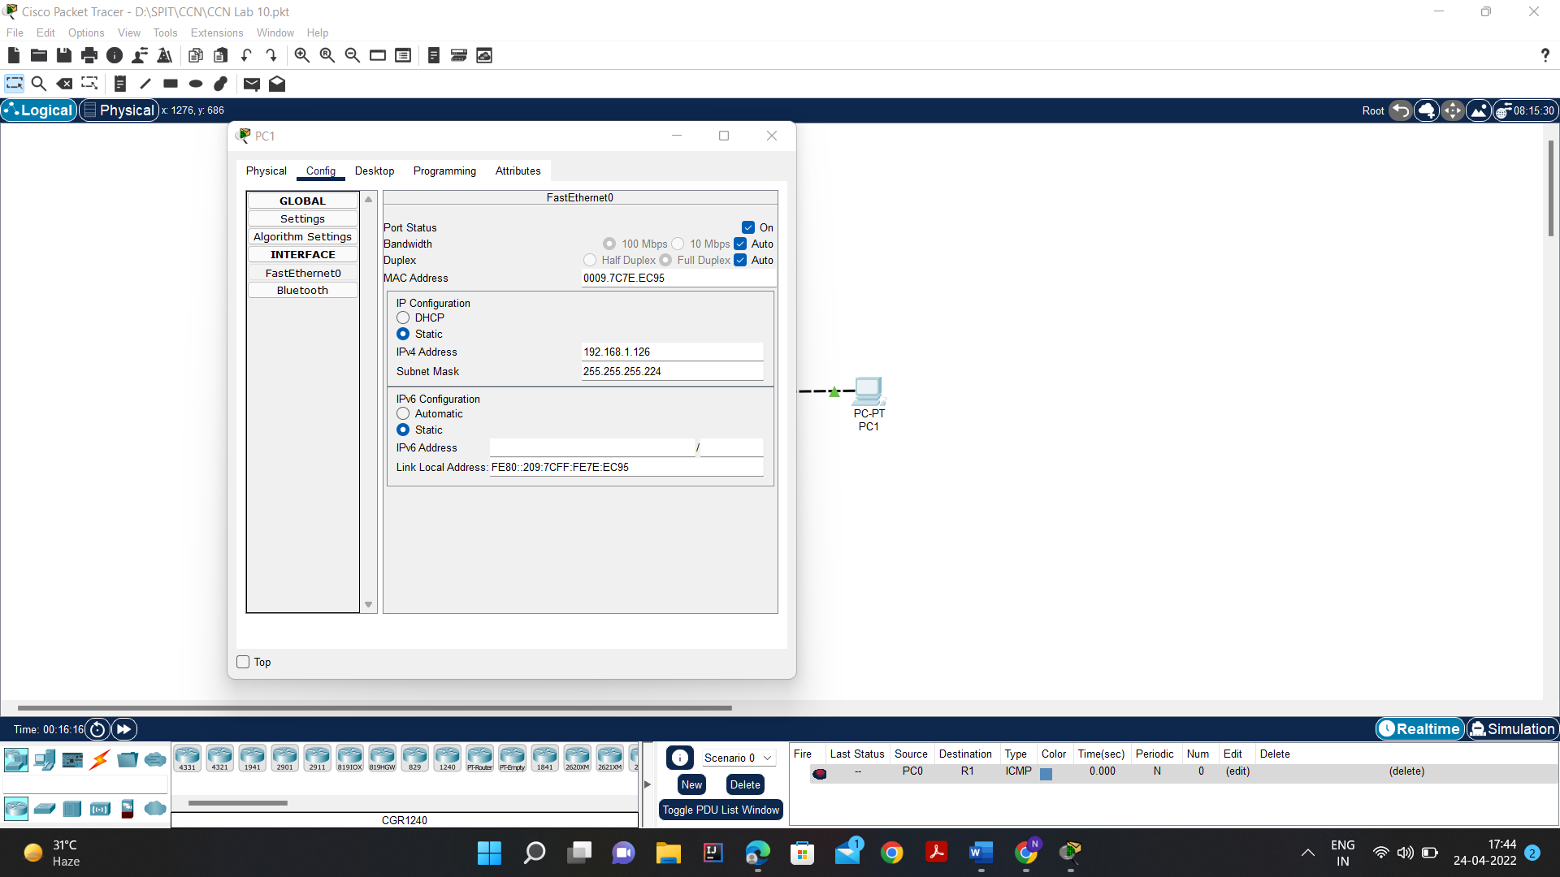

1. Document the addresses to be used in the table provide under the Topology Diagram.

**Task 3: Configure the Serial and FastEthernet Addresses.**

1. Configure the router interfaces.

Configure the interfaces on the R1 and R2 routers with the IP addresses from your network design.

Please note, to complete the activity in Packet Tracer you will be using the Config Tab. When you have finished, be sure to save the running configuration to the NVRAM of the router.

Router 1 FastEthernet0/0:

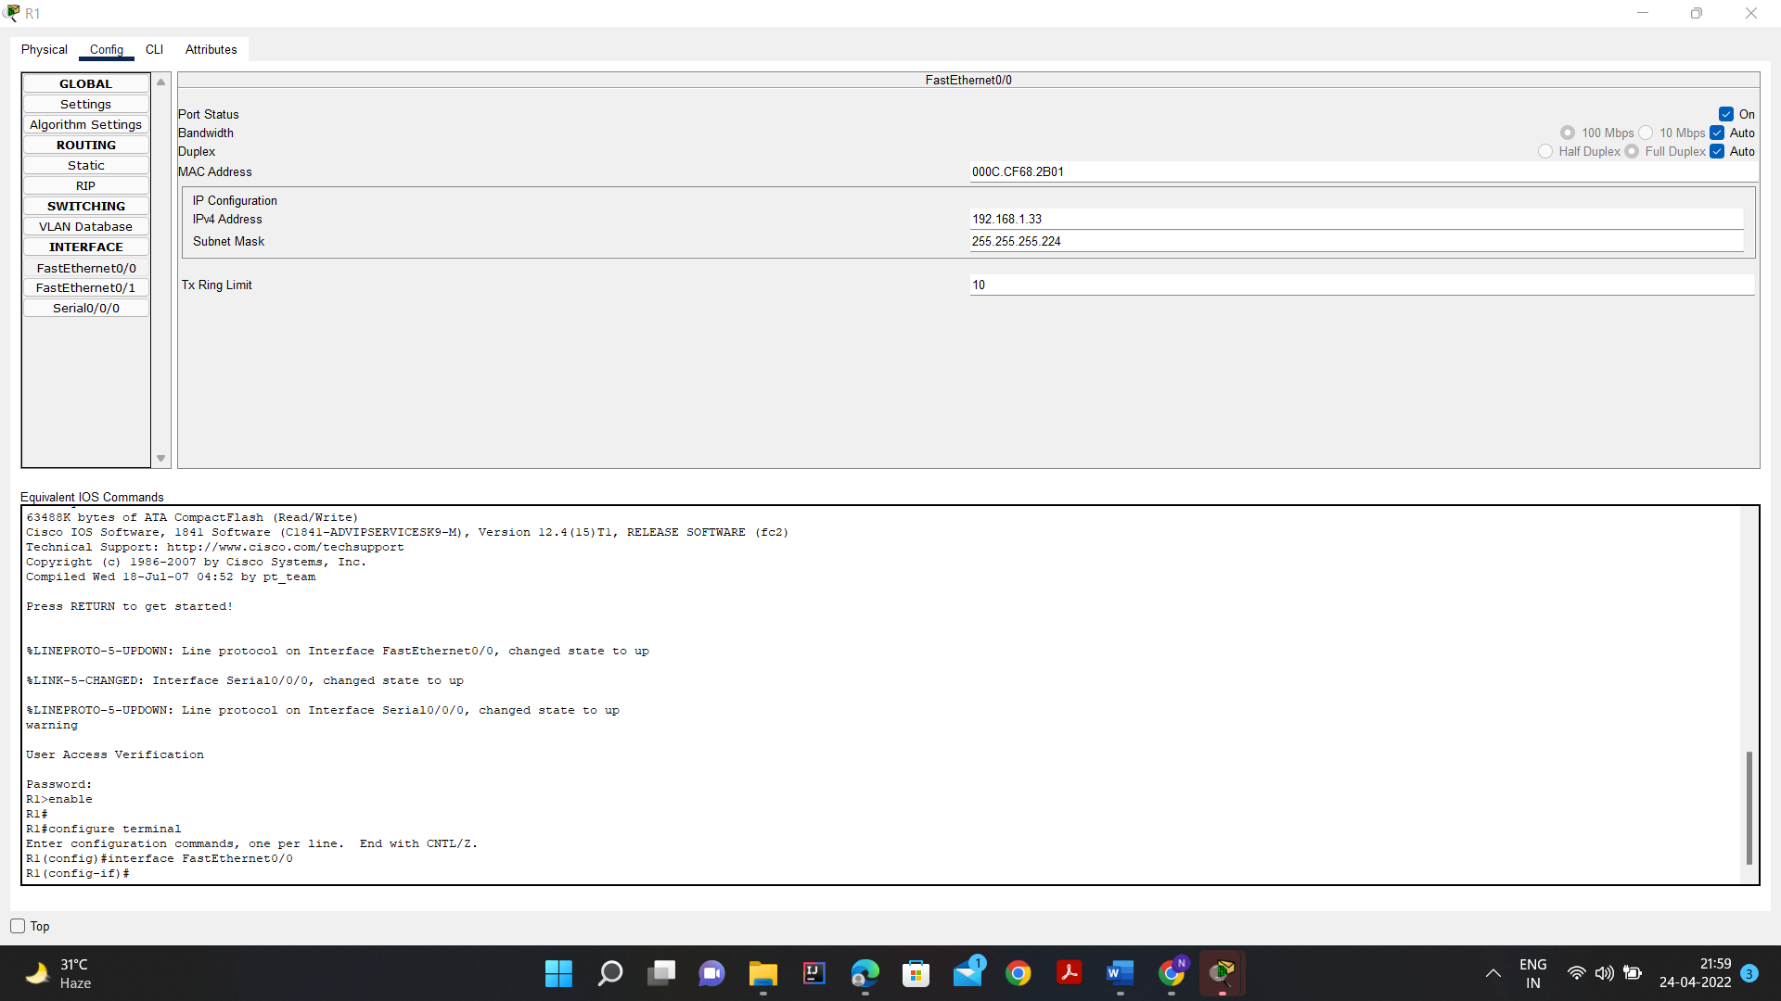

Router 1 Serial0/0/0:

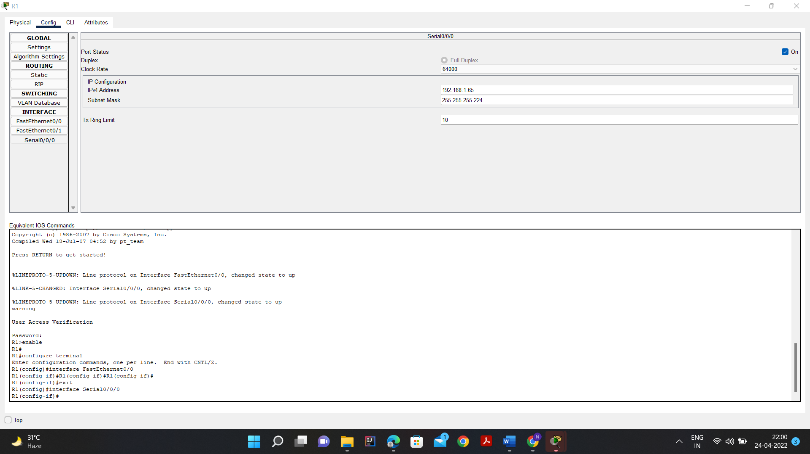

Router 2 FastEthernet 0/0: 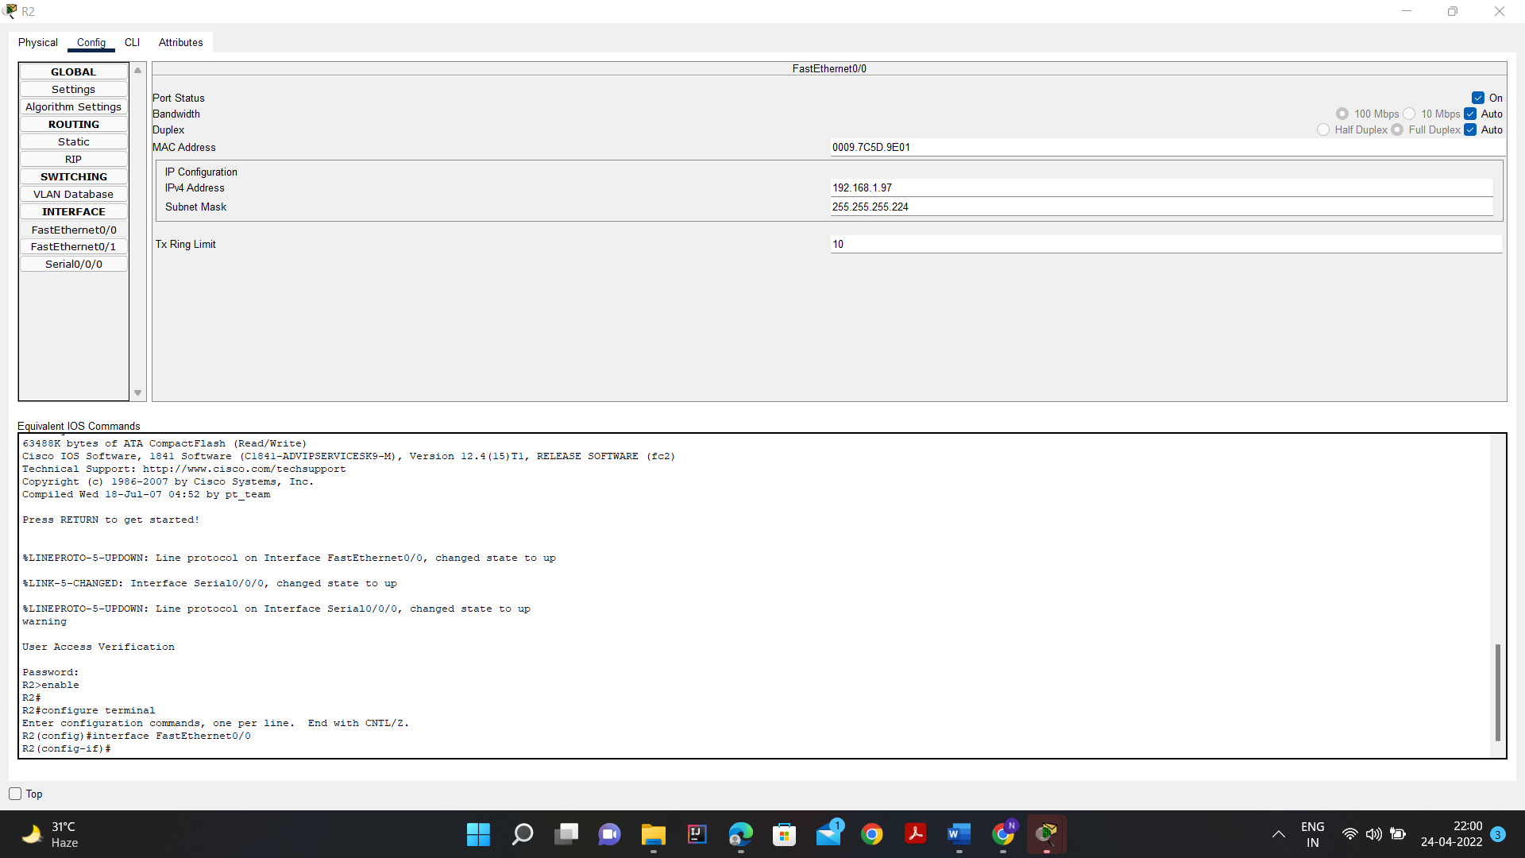

Router 2 Serial0/0/0:

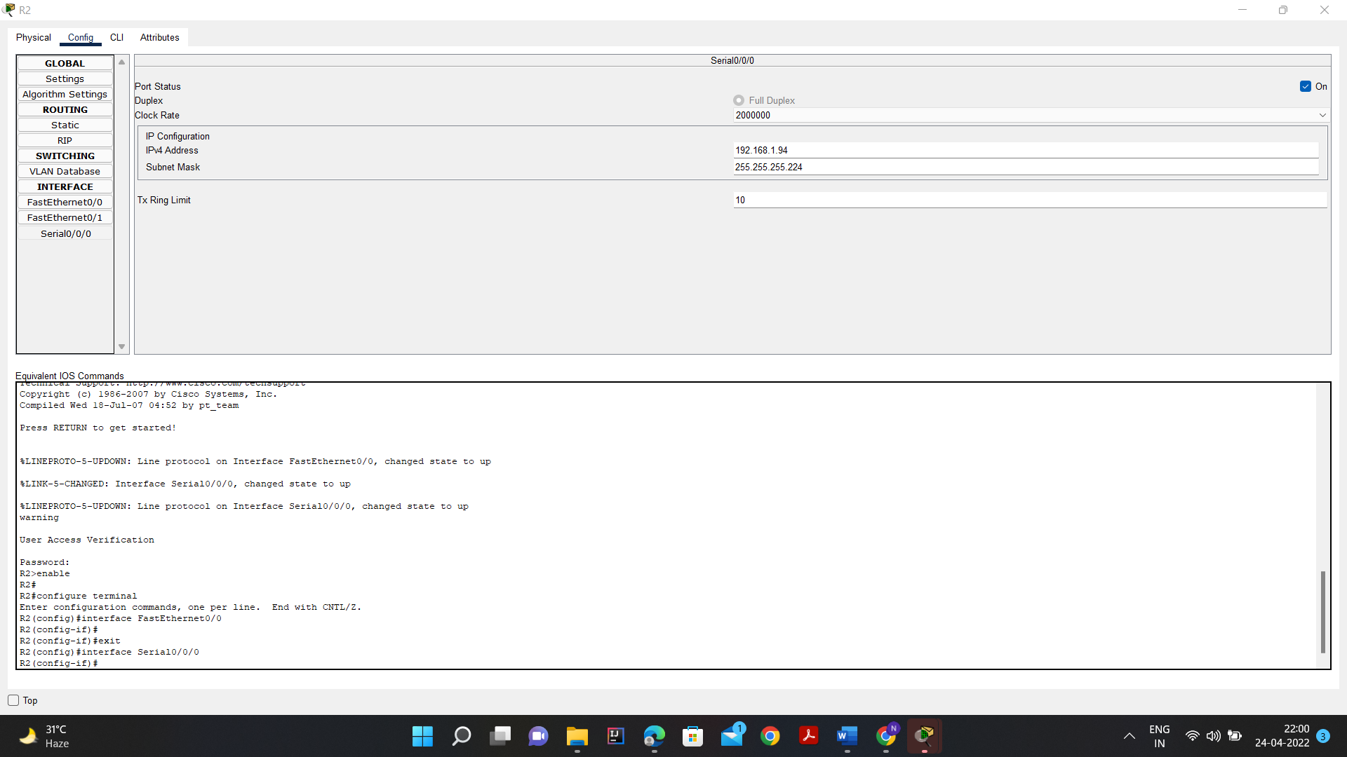

1. Configure the PC interfaces.

Configure the Ethernet interfaces of PC1 and PC2 with the IP addresses and default gateways from your network design PC1 has the default gateway of 192.168.1.33 which is the LAN address of R1

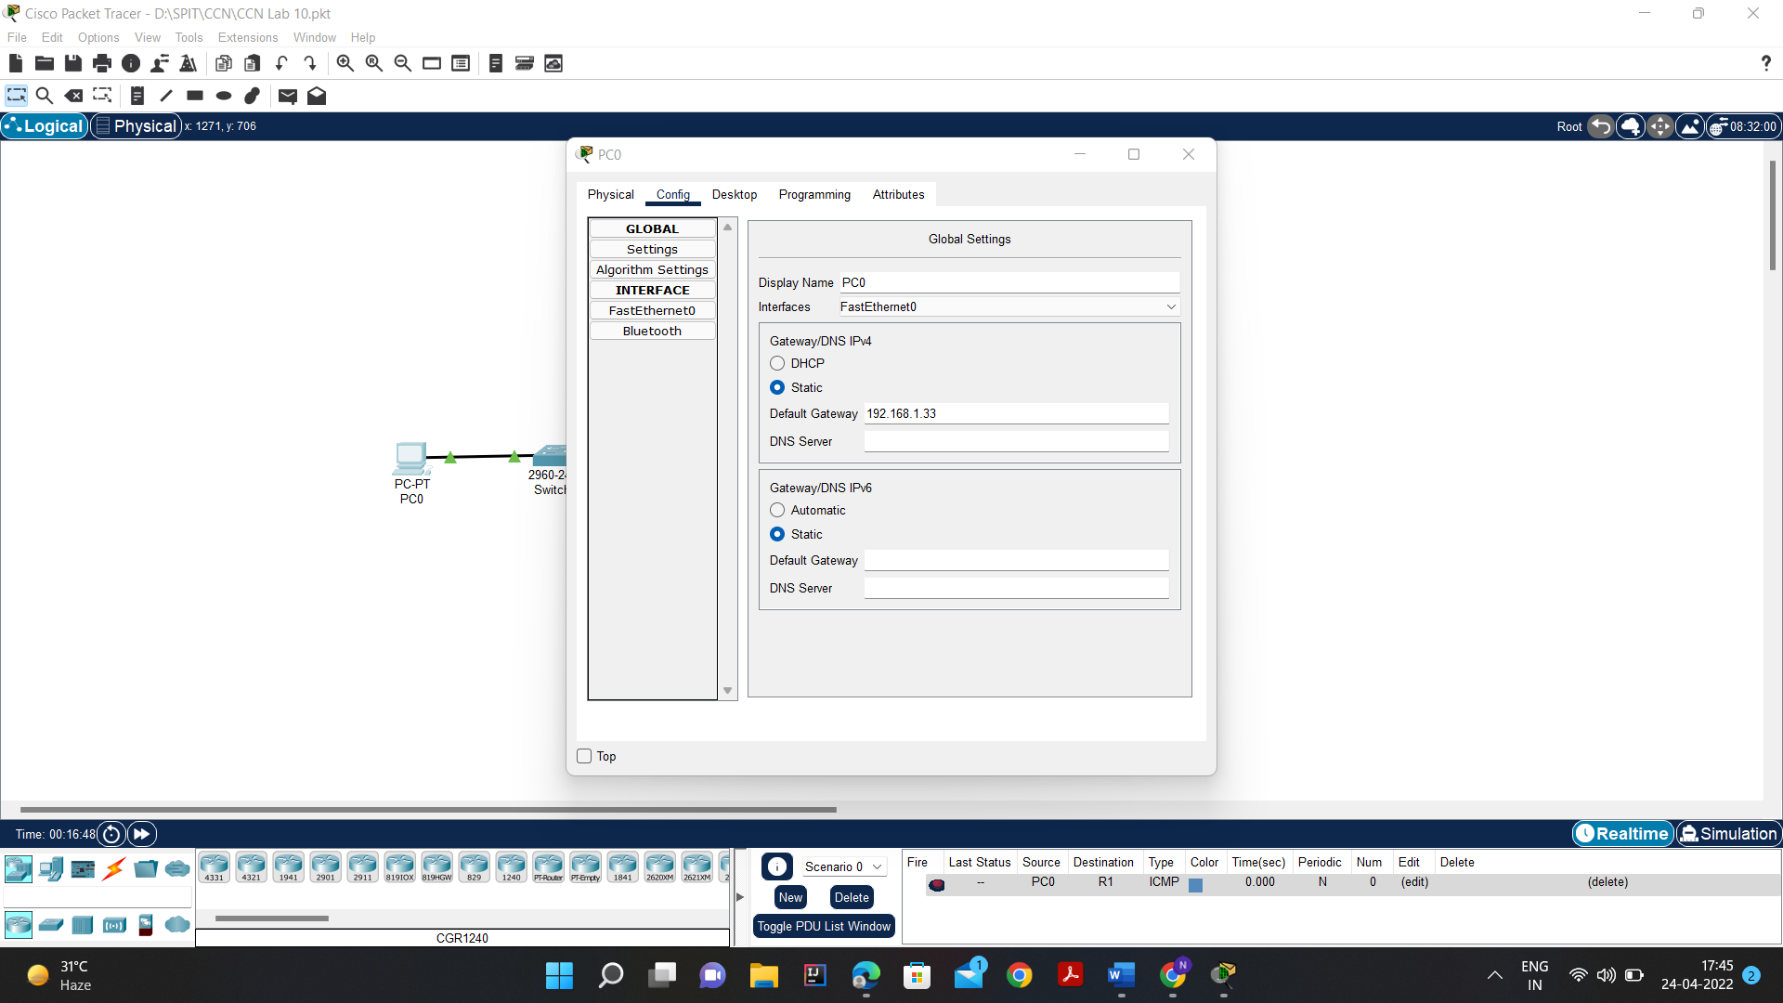

PC1 has the default gateway of 192.168.1.97 which is the LAN address of R2

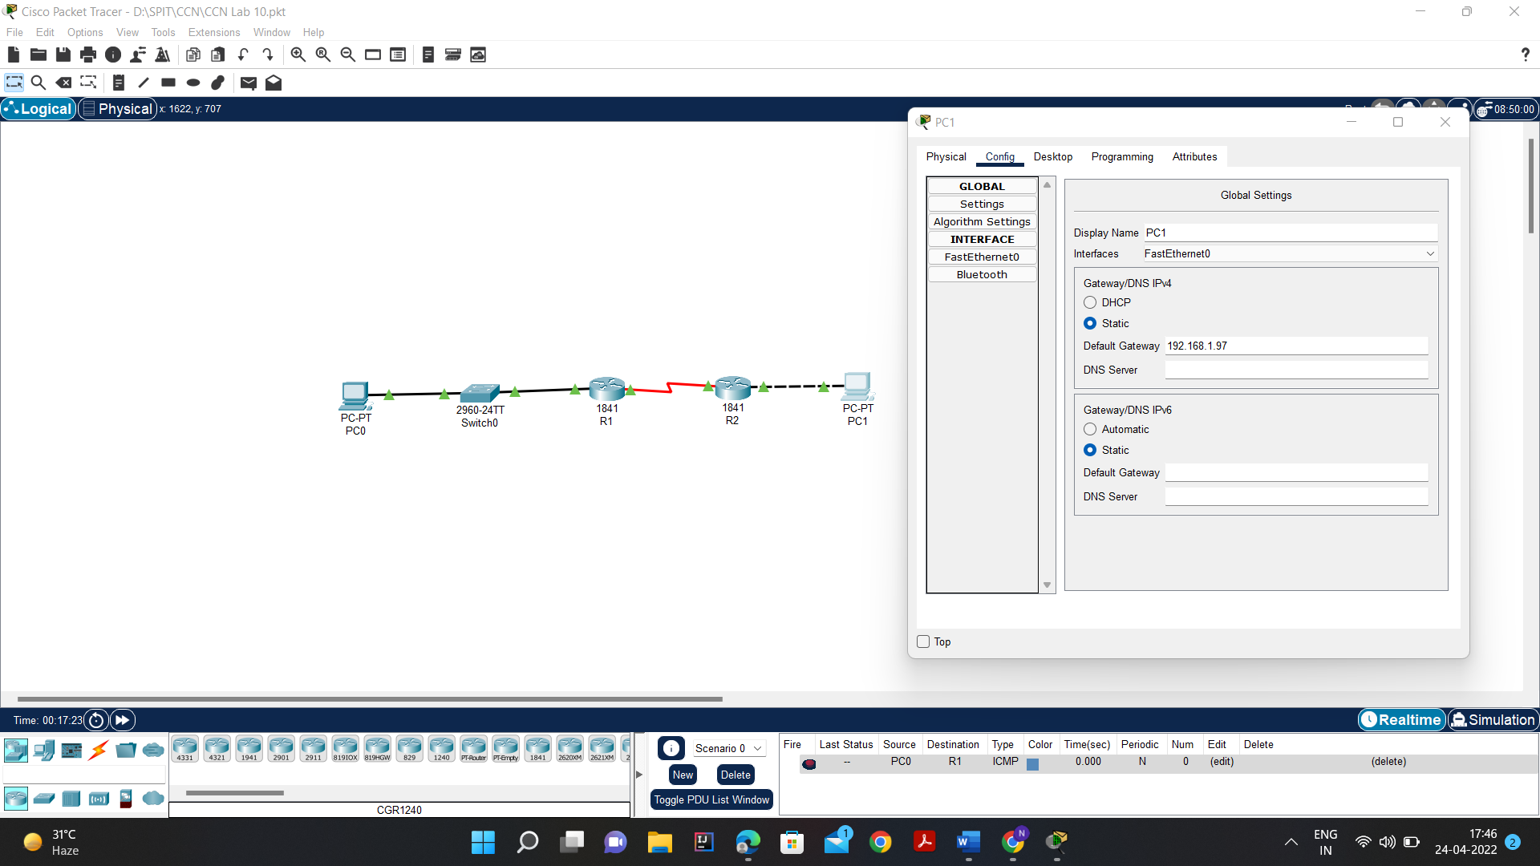

**Task 4: Verify the Configurations.**

Answer the following questions to verify that the network is operating as expected.

1. From the host attached to R1, is it possible to ping the default gateway?

* YES. As we can see in the image below it is possible to ping the default gateway 192.168.1.33 from R1 using the ping command.
* Output:

Pinging 192.168.1.33 with 32 bytes of data:

Reply from 192.168.1.33: bytes=32 time=1ms TTL=255

Reply from 192.168.1.33: bytes=32 time<1ms TTL=255

Reply from 192.168.1.33: bytes=32 time<1ms TTL=255

Reply from 192.168.1.33: bytes=32 time<1ms TTL=255

Ping statistics for 192.168.1.33:

Packets: Sent = 4, Received = 4, Lost = 0 (0% loss),

Approximate round trip times in milli-seconds:

Minimum = 0ms, Maximum = 1ms, Average = 0ms

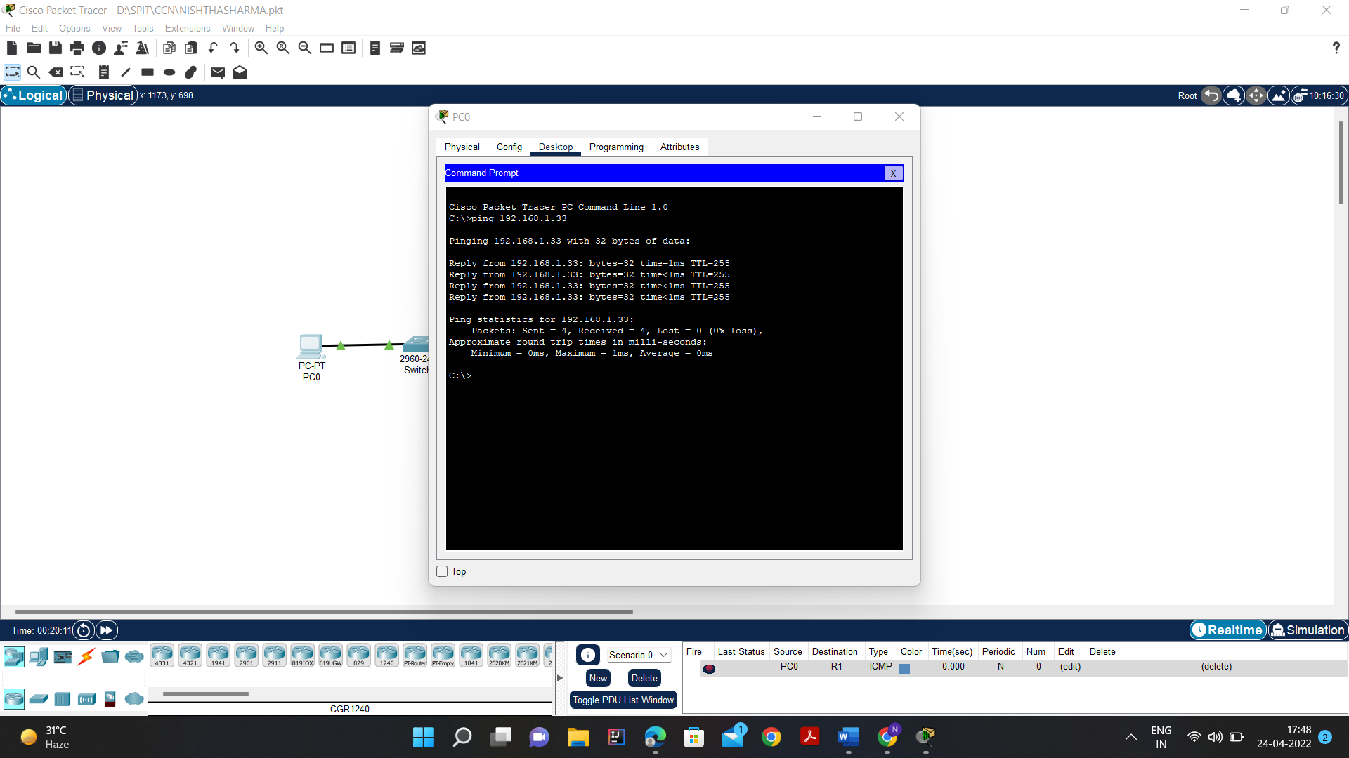

1. From the host attached to R2, is it possible to ping the default gateway?

* YES. As we can see in the image below It is possible to ping the default gateway 192.168.1.97 from R2 using the ping command.
* Output:

Pinging 192.168.1.97 with 32 bytes of data:

Reply from 192.168.1.97: bytes=32 time<1ms TTL=255

Reply from 192.168.1.97: bytes=32 time<1ms TTL=255

Reply from 192.168.1.97: bytes=32 time<1ms TTL=255

Reply from 192.168.1.97: bytes=32 time<1ms TTL=255

Ping statistics for 192.168.1.97:

Packets: Sent = 4, Received = 4, Lost = 0 (0% loss),

Approximate round trip times in milli-seconds:

Minimum = 0ms, Maximum = 0ms, Average = 0ms

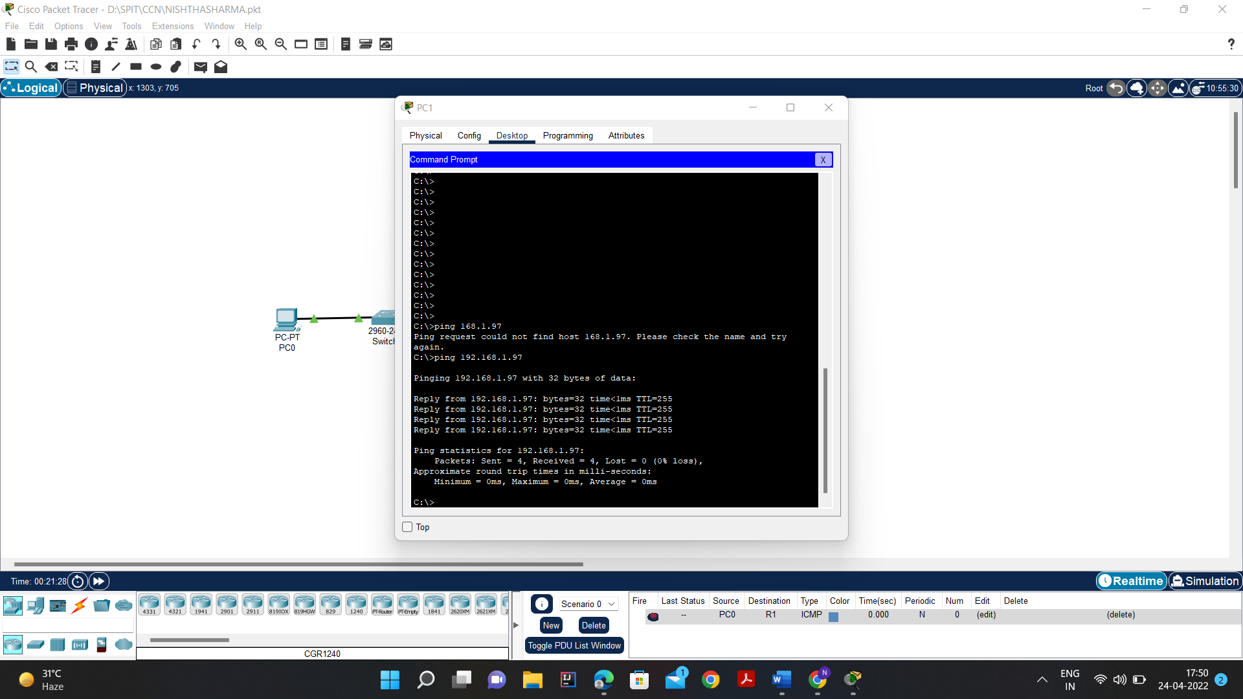

1. From the host attached to R1, is it possible to ping the default gateway?

* YES. As we can see in the image below It is possible to ping the default gateway 192.168.1.94 from R1 using the ping command.

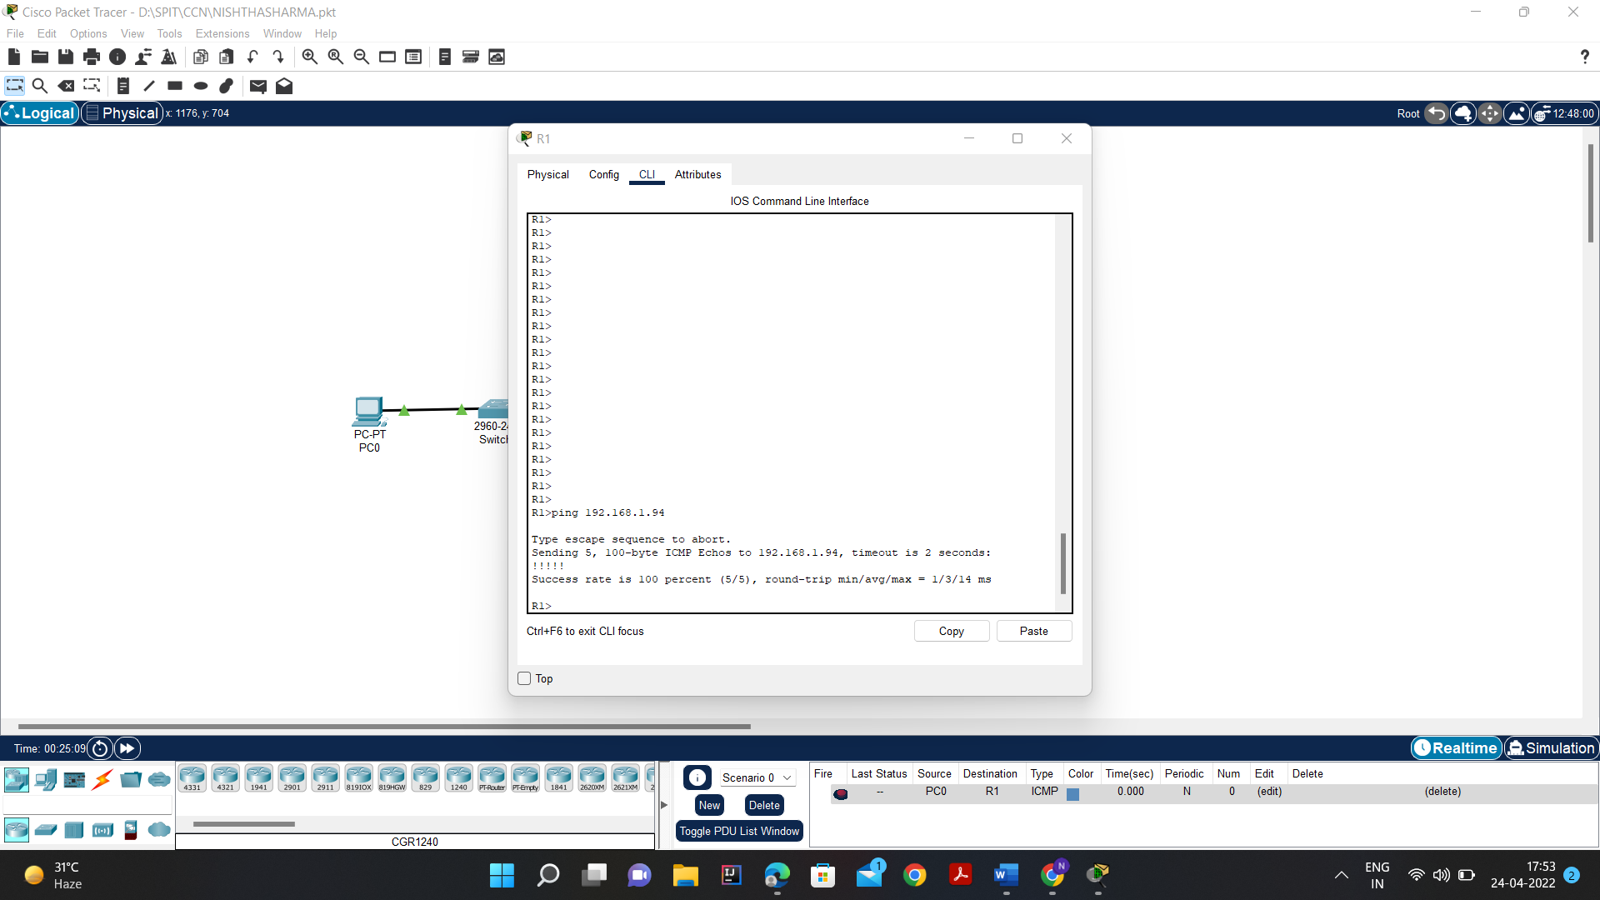

1. From the host attached to R2, is it possible to ping the default gateway?

* YES. As we can see in the image below It is possible to ping the default gateway 192.168.1.65 from R2 using the ping command.

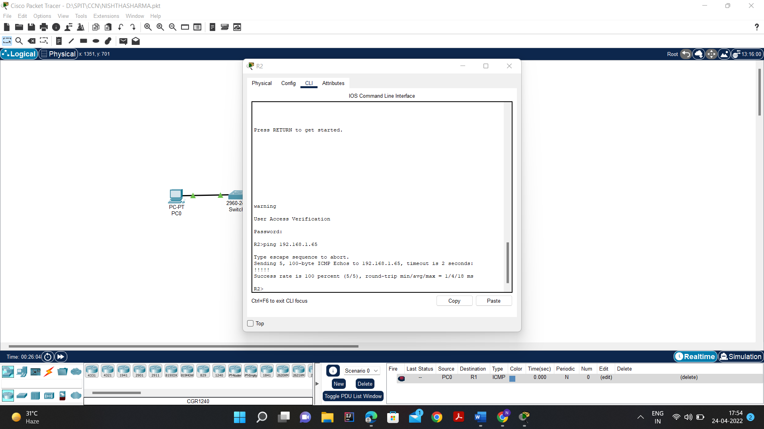

**Task 5: Reflection**

1. Are there any devices on the network that cannot ping each other?

* Yes. Any host on Network 1 cannot ping a host on Network 2 since these are local networks and not connected with each other. Hence, we deduce that PC1 cannot ping PC2 in this topology.

1. What is missing from the network that is preventing communication between these devices?

* No routing or switches are setup to enable across network packets that is why there is a break between communication.

CONCLUSION:

* Thus, I have understood what is cisco packet tracer and why is it used to help in learning network topologies.
* I have successfully installed the cisco packet tracer and configured it in my system.
* I learnt about subnet and masks.
* I successfully created a network topology with router, switch and pc, established connection between them and implemented their configuration and tested the connection using ping command.